SIMATS ENGINEERING

CSA15 – CLOUD COMPUTING AND BIG DATA ANALYTICS

ASSIGNMENT 3 – CO3

OBE-Based Evidence Principle
Design a Cloud-Based Collaborative Solution
CO3: Implement cloud-based solutions using cloud storage, web APIs, and platform services for real-world applications.

Field | Details | Field | Details
Student Name | M.Balaji | Register Number | 192525059
Department / Section | AIML | Academic Year / Semester | 2026
Faculty Name |  | Nature of Assignment | Individual
Duration | 1 Week | Total Marks | 50
Submission Date |  | Evaluation Date

MARK SHEET (Rubric-based evaluation)
Task | Title | Max | Awarded | Evidence / evaluation focus
1 | Accessing Cloud Services through Different Methods | 6 |  | Access-method diagram; demonstration; screenshots; comparison
2 | Cloud Platforms and Web Applications | 7 |  | Two platforms; interaction diagram; app demonstration; evaluation
3 | Web APIs for Cloud Access | 7 |  | API design; executable client; two requests; responses
4 | Cloud Security and Network Access | 7 |  | Secure-access architecture; threats; authentication; mitigations
5 | Collaboration Using Cloud-Based Services | 6 |  | Shared workspace; permissions; edits; contribution evidence
6 | Integrated Cloud Access and Collaboration Mini Investigation | 7 |  | Scenario; architecture; prototype; two user tests; evaluation
7 | Day-4 Design Challenge: Cloud-Based Collaborative Solution | 10 |  | Two independent proposals; comparison; joint design; validation; defence
 | TOTAL | 50 |  | Percentage:

OVERALL REMARKS:

Student Signature | Faculty Signature | Program Director

MANDATORY SUBMISSION EVIDENCE CHECK

✓ = Present in documented answer; P = Partly present; ✗ = Missing / not satisfied
Task | Evidence expected | Status | Evaluator note
1 | Three access methods,  client–network–cloud diagram, demonstration and observations |  | Access-method classification and practical access screenshots to be checked.
2 | Two-platform comparison, interaction diagram and cloud web-app demonstration |  | Platform mapping, user-action sequence and local-versus-cloud evaluation to be checked.
3 | API flow, program, two request inputs, responses and execution evidence |  | Code, actual request/response outputs and analysis to be checked.
4 | Secure-access flow, four security considerations, threat and mitigation analysis |  | Authentication, authorization and secure-communication evidence to be checked.
5 | Shared workspace, permission settings, two collaborative activities and contributions |  | Verify shared editing, user roles, permissions and contribution screenshots.
6 | Integrated scenario, architecture, prototype, two user scenarios and results |  | Verify cloud access, collaboration workflow, tests and limitations.
7 | Two initial proposals, comparison record, joint design, tests and cross-defence |  | Verify independent proposals, joint decisions, observed results and both students’ understanding.

IMPLEMENTATION EVIDENCE CHAIN
Evidence item | Status | Observation
Cloud access methods |  | Browser, mobile and API access methods explained.
Cloud platforms |  | Two cloud platforms and their applications compared.
Cloud access  demonstration |  | Actual screenshots need verification.
Web API implementation |  | Program and execution outputs need verification.
Cloud security |  | Authentication, authorization and security measures explained.
Cloud collaboration |  | Shared workspace and editing evidence need verification.
Mini-project |  | Design included; practical testing needs verification.
Day-4 design challenge |  | Individual proposals, joint design and validation need verification.
Student contributions |  | Contributions of both students need confirmation.
Screenshots |  | Original execution screenshots required.

SUBMISSION CHECKLIST (Not Separately Marked)
Requirement | Status
All 7 questions answered | - Yes ☐ Partly ☐ No
Cloud access methods explained | - Yes ☐ Partly ☐ No

Cloud architecture diagrams included | - Yes ☐ Partly ☐ No
Two cloud platforms compared | - Yes ☐ Partly ☐ No
Web API program and testing completed | - Yes ☐ Partly ☐ No
Cloud security explained | - Yes ☐ Partly ☐ No
Cloud collaboration demonstrated | - Yes ☐ Partly ☐ No
Mini-project completed and tested | - Yes ☐ Partly ☐ No
Day-4 design challenge completed | - Yes ☐ Partly ☐ No
Student A and B contributions recorded | - Yes ☐ Partly ☐ No
Screenshots and practical evidence attached | - Yes ☐ Partly ☐ No
Viva recommended | - Yes ☐ No

CLOUD COMPUTING AND BIG DATA ANALYTICS ASSIGNMENT 3 – CO3
CO3: Implement cloud-based solutions using cloud storage, web APIs, and platform services for real-world applications.

Mode: Pair Work – 2 Students per Group
Duration: 1 Week Total Marks: 50

OBE-Based Evidence Principle
The assignment requires students to demonstrate measurable evidence of: Understand → Design → Implement → Demonstrate → Analyse → Evaluate
Both students must understand the complete assignment. Students should not simply divide questions between them. Individual responsibilities are assigned within each question so that the contribution and attainment of CO3 can be independently verified.

Q1 – Accessing Cloud Services through Different Methods 6 Marks
Shared Group Work
Together, the pair must:
- Identify different methods of accessing cloud services.
- Study browser-based/cloud console access.
- Study access through mobile applications.
- Study access through APIs.
- Identify the role of Internet/network connectivity.
- Select one suitable cloud service for demonstration.

Student A – Access Method Design
Student A must individually:
- Identify and classify at least three cloud access methods.
- Prepare a simple architecture/flow diagram showing:
Client → Network → Cloud Service
- Explain how a user accesses the selected cloud service.
- Identify the hardware/software requirements.
- Explain the role of the client and network.
- Justify which access method is most suitable for the selected application.

Student B – Practical Evidence
Student B must individually:
- Demonstrate access to a cloud service using one selected method.
- Record the steps/screenshots as evidence.
- Test the access using different devices or access methods where possible.
- Record observations such as accessibility, response, and usability.
- Identify one limitation encountered during access.
- Explain how the limitation can affect cloud usage.

Cross-Verification
Student A must be able to explain Student B's practical demonstration. Student B must be able to explain Student A's access architecture.
Evidence Expected: Architecture diagram + screenshots/observations + comparison.

Q2 – Cloud Platforms and Web Applications 7 Marks
Shared Group Work
Together:

- Select two cloud platforms/services.
- Identify the web applications available through them.
- Study how users interact with the applications.
- Identify the cloud resources/services supporting the application.
- Prepare a comparative observation.

Student A – Platform Analysis
Student A must individually:
- Identify the major components of the selected cloud platform.
- Explain how the platform supports web applications.
- Map the user request to the cloud service.
- Explain the role of the Internet, server/cloud infrastructure and application.
- Prepare a simple interaction diagram. Student B – Application Investigation Student B must individually:
- Select one real-world cloud-based web application.
- Demonstrate its major functions.
- Record the sequence of user actions.
- Identify where cloud access is involved.
- Collect screenshots/evidence of the demonstration.
- Analyse the benefits of using the cloud-based application.

Joint Evaluation
Together answer:
If the same application were installed and operated only on a local computer, what limitations might users experience compared with accessing it through the cloud? Evidence Expected: Platform/application mapping + demonstration evidence + evaluation.

Q3 – Web APIs for Cloud Access 7 Marks
Shared Group Work
Together:
- Study the concept of a Web API.
- Identify how APIs enable application-to-cloud communication.
- Select a simple publicly accessible API or cloud API.
- Develop a small program/client to send a request.
- Observe and record the response. Student A – API Design and Understanding Student A must individually:
- Explain the purpose of the selected API.
- Identify the request and response components.
- Represent the API communication using a flow diagram.
- Explain the role of:
  - Client
  - API request
  - Cloud/server
  - API response
- Explain how APIs enable programmatic cloud access.

Student B – Implementation and Evidence
Student B must individually:
- Implement a simple API request using Python or another suitable language.
- Execute the program.
- Record input/request and output/response.
- Test at least two different requests or inputs.
- Capture execution evidence.
- Analyse the observed results.

Joint Analysis

Together determine:

Why is API-based access useful when a large number of users/applications need to communicate with a cloud service automatically?
Evidence Expected: Program + execution screenshots + request/response evidence + analysis.

Q4 – Cloud Security and Network Access 7 Marks
Shared Group Work
Together:
- Identify security issues involved in accessing cloud services.
- Study authentication and authorization.
- Study secure network communication.
- Identify possible threats during cloud access.
- Prepare a secure cloud-access scenario.

Student B – Security Design
Student B must individually:
- Identify at least four security considerations for cloud access.
- Explain authentication and authorization.
- Explain the importance of secure communication.
- Design a secure access flow:
User → Authentication → Network → Cloud Service → Authorization → Resource
- Identify possible points of attack.
- Suggest suitable security measures. Student A – Security Investigation Student A must individually:
- Investigate a practical cloud-access security scenario.
- Demonstrate or document a suitable authentication mechanism where feasible.
- Compare secure and insecure access situations conceptually.
- Record observations.
- Explain how poor security practices can affect cloud users and data.

Joint Evaluation
Together answer:

If cloud access is available from anywhere through the Internet, what additional security measures are necessary compared with a local application?
Evidence Expected: Secure-access architecture + threat identification + mitigation analysis.

Q5 – Collaboration Using Cloud-Based Services 6 Marks
Shared Group Work
Together:
- Select a cloud collaboration platform/service.
- Create a shared document/folder/project space.
- Configure appropriate sharing permissions.
- Perform collaborative editing.
- Record the collaboration process. Student A – Collaboration Design Student A must individually:
- Identify the collaboration requirements.
- Design a suitable cloud collaboration workflow.
- Explain:
  - Sharing
  - Concurrent access
  - Version control
  - Permission management

- Identify the roles of different users.
- Justify the selected sharing permissions. Student B – Collaborative Implementation Student B must individually:
- Participate in the shared cloud workspace.
- Perform at least two collaborative activities.
- Record evidence of contribution.
- Demonstrate sharing/permission settings.
- Observe how changes made by users are reflected.
- Identify one collaboration issue and suggest a solution.

Cross-Understanding
Student B must explain:

How does cloud collaboration reduce the need to exchange multiple copies of the same file?
Student A must explain:

What problems can occur if incorrect sharing permissions are given?
Evidence Expected: Shared workspace + contribution evidence + permission screenshots
+ observations.

Q6 – Integrated Cloud Access and Collaboration Mini Investigation 7 Marks
Students must design a small real-world scenario that requires both cloud access and cloud collaboration.

Suggested Scenarios
Choose one:
- Cloud-based Student Project Management
- Online Student Attendance and Faculty Collaboration
- Cloud-Based Event Management
- Cloud-Based Assignment Submission and Evaluation
- Cloud-Based Hospital Appointment Coordination
- Cloud-Based Disaster Information Sharing
- Cloud-Based College Placement Coordination

Student A – System Design
Student A must individually:
  - Define the problem.
  - Identify users.
  - Identify cloud access methods.
  - Identify required cloud services.
  - Design the system architecture.
  - Explain how users access the system.
  - Explain how users collaborate. Student B – Evidence and Evaluation Student B must individually:
  - Develop a small prototype/mock-up/workflow where feasible.
  - Demonstrate at least one cloud access mechanism.
  - Demonstrate one collaboration mechanism.
  - Record screenshots/evidence.
  - Test the proposed solution using at least two user scenarios.
  - Analyse the results.
  - Identify limitations and possible improvements.

Joint Evaluation
Together answer:
How does combining cloud access and cloud collaboration improve the efficiency of the proposed system?

Q7 – DAY-4 DESIGN CHALLENGE

Design a Cloud-Based Collaborative Solution 10 Marks
This question must be solved collaboratively.
Neither student should independently prepare the complete solution and combine it later.

Stage 1 – Independent Design Proposal
Before discussing with each other:

Student A independently proposes:
  - Problem definition
  - Target users
  - Cloud access method
  - Required cloud services
  - Collaboration mechanism
  - Basic architecture

Student B independently proposes:
  - Problem definition
  - Target users
  - Cloud access method
  - Required cloud services
  - Collaboration mechanism
  - Basic architecture
Both initial proposals must be retained as evidence.

Stage 2 – Compare the Two Designs
Together discuss:
  - Where the designs agree
  - Where they differ
  - Strengths and weaknesses
  - Security concerns
  - Accessibility
  - Collaboration requirements
  - Missing components
  - Which ideas should be retained Prepare a Design Comparison Record.

Stage 3 – Joint Final Design Develop the final cloud-based solution. The final design must identify:
  - Problem
  - Users
  - Cloud access method
  - Network requirements
  - Cloud service/platform
  - Web application/API requirement
  - Collaboration mechanism
  - Authentication/security

  - Data/resource sharing
  - Complete system workflow Prepare an architecture such as:

Users → Client → Internet/Network → Cloud Platform → Application/API → Shared Resources

Stage 4 – Validation

Student A – Technical Validation

Student A must:
  - Explain the selected cloud access method.
  - Justify the platform/service selection.
  - Explain the system architecture.
  - Explain how API/web access is used, if applicable.
  - Analyse the suitability of the design.

Student B – Experimental Validation

Student B must:
  - Design test cases.
  - Demonstrate the solution/workflow.
  - Test different users/access conditions.
  - Record observations.
  - Present screenshots or other evidence.
  - Compare expected and observed behaviour.

Stage 5 – Cross-Defence

Student A must explain:

What experimental evidence supports the group's cloud design?

Student B must explain:

Why was the selected cloud access and collaboration approach chosen?

Stage 6 – Joint Evaluation

Together determine:
  - Benefits of the proposed cloud solution
  - Access-related limitations
  - Collaboration benefits
  - Security risks
  - Scalability considerations
  - Possible improvements
  - Situations where the proposed approach may not be appropriate
Final Question

What characteristics should a system designer consider before selecting cloud-based access and collaboration for a real-world application?

CONTRIBUTION RECORD

Each pair must include the following table at the end of the submission.
Question | Student A – Primary Contribution | Student B – Primary Contribution | Joint Work
Q1
Q2
Q3
Q4
Q5
Q6
Q7
The contribution record must reflect the actual work completed.
Primary contribution does not mean exclusive responsibility. Both students are accountable for the complete assignment.

INDIVIDUAL VERIFICATION – OBE EVIDENCE
Faculty may select any question or component for individual verification. Each student must be able to:
  - Explain the cloud access method.
  - Explain the role of client, network and cloud service.
  - Explain web application/API access.
  - Explain security considerations.
  - Demonstrate cloud collaboration.
  - Interpret experimental evidence.
  - Justify design decisions.
  - Respond to a modified requirement or scenario. A student should not answer:

“My partner did this section.”
Understanding of the complete submitted work is mandatory.

RECOMMENDED FACULTY VERIFICATION MODEL – VIVA
For each student, conduct a brief 4–5 minute verification. Question 1 – Primary Responsibility
Ask one technical question from the component for which the student had primary responsibility.

Question 2 – Partner's Responsibility
Ask one question from a component primarily completed by the partner.

Question 3 – Transfer Question
Modify a condition and ask the student to reason about the consequence.

Examples:
“If Internet connectivity becomes unreliable, how would it affect cloud access?”
“If a shared cloud document is given editing permission to everyone, what problems could occur?”
“If the API becomes unavailable, how would your application behave?”
“If a user is authenticated but does not have permission to access a resource, what should happen?”

This provides individual evidence of CO3 attainment without requiring two completely separate assignments.

OBE Evidence Mapping
CO3 Component | Assignment Evidence
Build methods to access cloud | Q1, Q2, Q3
Access through platforms/web applications | Q2
Programmatic/API-based access | Q3
Secure cloud access | Q4
Collaboration within cloud | Q5
Apply cloud access + collaboration | Q6
Design and evaluate a cloud solution | Q7
Individual attainment | Viva + contribution record
Practical evidence | Screenshots, programs, observations, test results
Higher-order learning | Design, analysis, evaluation and transfer questions

Q1 – Accessing Cloud Services through Different Methods (6 Marks)

Shared Group Work
Cloud services are delivered over a network and are not tied to one physical machine. A user reaches them through a client, and there are three common methods: a web browser or cloud console, a mobile application, and a programmatic interface (API, command-line tool or SDK). All three depend on Internet or network connectivity between the client and the provider’s data centre.
- Browser / cloud console access: the user opens a URL, signs in and uses the service through a web interface. No installation is needed.
- Mobile application access: a dedicated app on a phone or tablet talks to the same cloud back end and adds features such as camera upload and notifications.
- API access: a program sends HTTP requests to the service and processes the response, so the service can be used without a human interface.
- Role of connectivity: the Internet carries every request and response; speed, latency and reliability of the connection decide how usable the service feels.
Selected service for demonstration: Google Drive (cloud storage), because it can be reached through all three methods.

Student A – Access Method Design

1. Classification of cloud access methods
Access method | How the user connects | Requirements | Example with Google Drive
Browser / web console | Opens the service URL in a browser and signs in with an account | Any device with a modern browser and an Internet connection | drive.google.com in Chrome or Edge
Mobile application | Installs the vendor’s app and signs in once; the app syncs with the cloud | Smartphone or tablet (Android / iOS), app installed, mobile data or Wi-Fi | Google Drive app on Android
API / programmatic access | A program sends authenticated HTTP requests to the service endpoint | Programming language, HTTP library, API credentials, Internet connection | Google Drive REST API called from Python

2. Architecture / flow diagram
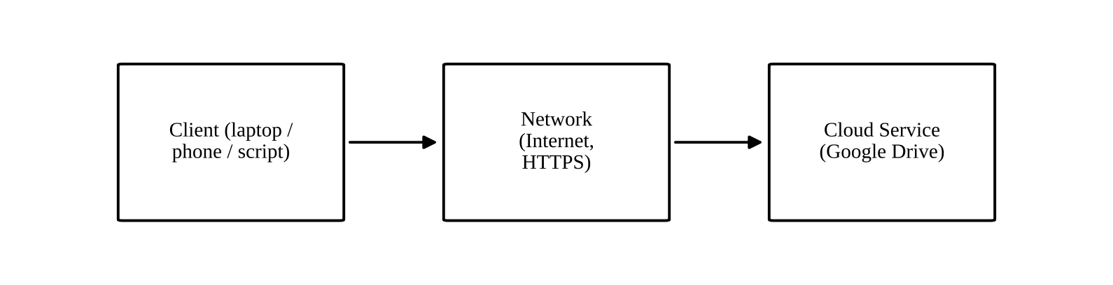
Figure 1: Client → Network → Cloud Service

3. How a user accesses the selected service
The user starts a client (browser, app or program) and enters credentials. The client sends an HTTPS request across the Internet to the provider’s servers. The cloud service authenticates the user, checks permissions, reads or writes the stored data and returns the result. The client then displays the file list or downloads the selected file.

4. Hardware and software requirements
- Hardware: laptop, desktop, tablet or smartphone; a network interface (Wi-Fi, Ethernet or mobile data); enough free memory to run the browser or app.
- Software: an up-to-date browser or the Drive mobile app; operating system supporting TLS; for API use, Python with the requests library and valid credentials.

5. Role of the client and the network
The client is the user’s entry point: it collects input, encrypts and sends requests, and presents results. The network is the transport path that carries those requests to the cloud and the responses back. The cloud service performs storage, processing and access control. If the client or the network is weak, the experience degrades even though the service itself is healthy.

6. Most suitable access method
For collaborative student work with Google Drive, browser access is the most suitable method. It needs no installation, works on any operating system, gives the full feature set (sharing, comments, version history) and keeps nothing on the local machine. The mobile app is a good second choice for quick viewing, and API access is best reserved for automation.

Student B – Practical Evidence

1. Steps followed to access Google Drive through the browser
- Step 1: Open a browser and enter drive.google.com.
- Step 2: Sign in with the user account (username, password and verification step).
- Step 3: The My Drive page loads and lists folders and files.
- Step 4: Create a folder named “CO3_Assignment” and upload a sample file.
- Step 5: Open the file, confirm it displays correctly, then sign out.

2. Testing with different devices / access methods
Device and method | What was checked | Observation (accessibility, response, usability)
Laptop – browser | Sign in, create folder, upload file | Full feature set available; fastest response; easiest to use on a large screen
Smartphone – Drive mobile app | Sign in, view and upload photo | Convenient for quick access and camera upload; smaller screen limits detailed editing
Smartphone – mobile browser | Open drive.google.com | Works, but redirects to the app for some actions; layout is compact

3. Limitation encountered and its effect
Limitation: access depends completely on a working Internet connection. When the connection was slow or unavailable, files could not be opened or uploaded and the page stopped loading.
Effect on cloud usage: users cannot reach their data during an outage, uploads of large files may fail midway, and time-critical work (for example, submitting an assignment before a deadline) is put at risk. Mitigation includes enabling offline mode for important files, keeping a mobile-data backup connection and starting uploads early.

Cross-Verification
Student A is able to explain the practical demonstration recorded by Student B (the steps, devices and the connectivity limitation), and Student B is able to explain the client–network–cloud architecture and the classification of access methods prepared by Student A.
Evidence expected: architecture diagram (Figure 1) + screenshots/observations + comparison table above.

Q2 – Cloud Platforms and Web Applications (7 Marks)

Shared Group Work
Platforms selected: (1) Google Cloud / Google Workspace and (2) Microsoft Azure / Microsoft 365.
Aspect | Google Cloud / Workspace | Microsoft Azure / Microsoft 365
Web applications | Google Docs, Sheets, Slides, Drive, Gmail, Meet | Word Online, Excel Online, PowerPoint Online, OneDrive, Outlook, Teams
How users interact | Browser or mobile app, sign in with a Google account | Browser or mobile app, sign in with a Microsoft account
Supporting cloud services | Compute (Compute Engine, App Engine), Cloud Storage, Cloud SQL, identity services | Virtual Machines, App Service, Blob Storage, Azure SQL, Azure Active Directory (Entra ID)
Collaboration features | Real-time co-editing, comments, version history | Real-time co-authoring, comments, version history, Teams channels
Developer access | REST APIs and client libraries | REST APIs, Microsoft Graph, SDKs

Both platforms follow the same pattern: the user interacts with a web application in the browser, the request travels over the Internet, and platform services (compute, storage, database, identity) running in the provider’s data centres process it.

Student A – Platform Analysis

1. Major components of the selected platform (Google Cloud)
- Compute: virtual machines and managed application hosting that run the application code.
- Storage: object and file storage that holds documents, images and backups.
- Database: managed relational and NoSQL databases for structured application data.
- Networking: load balancers, virtual networks and DNS that route user traffic.
- Identity and access management: authentication, roles and permissions.

2. How the platform supports web applications
The platform hosts the application on managed compute resources, stores its data in cloud storage and databases, balances the load across servers and scales resources up or down according to demand. Developers publish the application once and the platform makes it available to users through a URL.

3. Mapping a user request to cloud services
User action | Cloud service involved
Types the web address and signs in | Identity and access management (authentication)
Page loads | Load balancer and web application servers (compute)
Opens a document | Cloud storage retrieves the file
Edits and saves | Application logic writes changes to storage and updates the database
Shares with a classmate | Access-control service updates permissions

4. Role of the Internet, cloud infrastructure and application
- Internet: carries requests and responses between the user device and the provider.
- Cloud infrastructure: servers, storage and networking that provide the processing power and capacity.
- Application: the software that implements the features the user sees, running on the infrastructure.

5. Interaction diagram
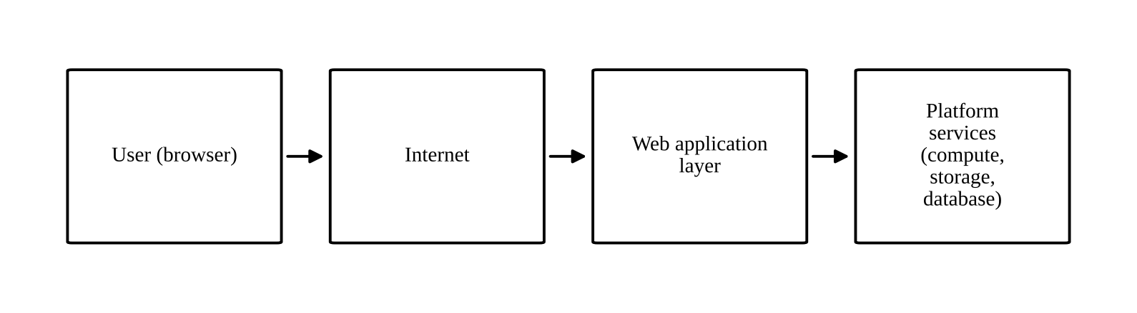
Figure 2: User request flow through a cloud platform

Student B – Application Investigation
Application selected: Google Docs, a real-world cloud-based word-processing application.

1. Major functions demonstrated
- Creating and formatting a document in the browser.
- Sharing the document with another user by link or email.
- Real-time editing by two users, with comments and suggestions.
- Viewing version history and restoring an earlier version.
- Downloading the document as Word or PDF.

2. Sequence of user actions and where cloud access is involved
Step | User action | Where cloud access is involved
1 | Open docs.google.com and sign in | Authentication by the cloud identity service
2 | Click Blank document | New file created in cloud storage
3 | Type and format text | Changes are saved automatically to the cloud
4 | Click Share and add a collaborator | Permission entry stored in the cloud
5 | Collaborator edits at the same time | Both users’ edits are merged on the server
6 | Open version history | Earlier versions retrieved from cloud storage

3. Benefits of the cloud-based application
- Access from any device with a browser; nothing to install or update.
- Automatic saving and version history reduce the risk of lost work.
- Real-time collaboration avoids exchanging multiple copies of a file.
- Storage and processing are provided by the cloud, so the user’s device needs few resources.

Joint Evaluation
Question: If the same application were installed and operated only on a local computer, what limitations might users experience compared with accessing it through the cloud?
- Access is limited to that one computer; files are not available from other devices unless copied manually.
- Collaboration is difficult: users must e-mail copies, which creates version conflicts.
- Backup depends on the user; a disk failure or theft can cause permanent loss.
- Installation, updates and licensing must be handled on every machine.
- Performance depends on local hardware, and capacity cannot be scaled on demand.
- On the other hand, a local installation keeps working without the Internet, which is the one clear advantage it retains.
Evidence expected: platform/application mapping (tables and Figure 2) + demonstration evidence (screenshots 3 and 4) + evaluation above.

Q3 – Web APIs for Cloud Access (7 Marks)

Shared Group Work
A Web API is a defined interface through which one program requests services or data from another over HTTP. Instead of a person clicking a web page, a client program sends a structured request to a URL (endpoint) and receives a structured response, usually in JSON. This lets applications talk to cloud services automatically.
Selected API: the GitHub REST API (https://api.github.com). It is publicly accessible, needs no registration for basic read requests and returns JSON, which makes it suitable for a small client program.

Student A – API Design and Understanding

1. Purpose of the selected API
The GitHub REST API gives programs access to information held on the GitHub cloud platform, such as user profiles and repository details, so that tools and applications can read or manage that data without using the web interface.

2. Request and response components
Part | Component | Example
Request | HTTP method | GET
Request | Endpoint URL | https://api.github.com/users/octocat
Request | Headers | Accept: application/vnd.github+json; User-Agent
Request | Parameters / path values | Username octocat in the path
Response | Status code | 200 OK (success), 404 Not Found, 403 Forbidden
Response | Headers | Content-Type: application/json
Response | Body | JSON object with login, name, public_repos, followers, etc.

3. Flow diagram of API communication
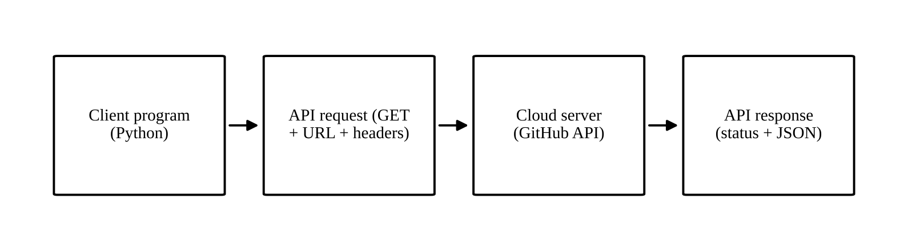
Figure 3: Web API request–response flow

4. Roles
- Client: the Python program that builds and sends the request and processes the result.
- API request: the message containing the method, URL and headers that states what the client wants.
- Cloud / server: the GitHub servers that validate the request, look up the data and build the reply.
- API response: the status code and JSON data returned to the client.

5. How APIs enable programmatic cloud access
APIs expose cloud functions in a standard, machine-readable form. Any program in any language that can send an HTTP request can use the service, so tasks such as reading data, uploading files or creating resources can be automated, scheduled and integrated with other systems without human interaction.

Student B – Implementation and Evidence

1. Program (Python)
import requests

BASE_URL = "https://api.github.com"
HEADERS = {"Accept": "application/vnd.github+json", "User-Agent": "co3-assignment-client"}

def call_api(path):
url = BASE_URL + path
print("REQUEST : GET", url)
response = requests.get(url, headers=HEADERS, timeout=10)
print("STATUS :", response.status_code, response.reason)
print("FORMAT :", response.headers.get("Content-Type"))
return response

# Request 1 - public user profile
r1 = call_api("/users/octocat")
d = r1.json()
print("login :", d.get("login"))
print("name :", d.get("name"))
print("public repos :", d.get("public_repos"))
print("followers :", d.get("followers"))
print("-" * 50)

# Request 2 - repository information
r2 = call_api("/repos/python/cpython")
d = r2.json()
print("full_name :", d.get("full_name"))
print("language :", d.get("language"))
print("license :", (d.get("license") or {}).get("spdx_id"))
print("open issues :", d.get("open_issues_count"))
print("-" * 50)

# Request 3 - invalid input (error handling)
r3 = call_api("/users/this-user-does-not-exist-co3-98765")
print("message :", r3.json().get("message"))

2. Execution: request/input and response/output
Output captured when Request 1 was executed (follower count is live data and changes over time):
REQUEST : GET https://api.github.com/users/octocat
STATUS : 200 OK
FORMAT : application/json; charset=utf-8
login : octocat
name : The Octocat
public repos : 8
followers : 24940

Requests 2 and 3 use the same function with a different path. Their expected responses are summarised below; the complete three-request run on the student’s own machine is shown in the screenshot.
Request | Expected status | Expected response content
GET /repos/python/cpython | 200 OK | JSON with full_name, language, license and open_issues_count
GET /users/this-user-does-not-exist-co3-98765 | 404 Not Found | JSON with message: Not Found

3. Requests tested
Test | Request (input) | Purpose
1 | GET /users/octocat | Valid request for a user profile
2 | GET /repos/python/cpython | Valid request for repository details
3 | GET /users/this-user-does-not-exist-co3-98765 | Invalid input to observe error handling

4. Analysis of observed results
- A valid request returns status 200 with a JSON body, from which the program extracts the fields it needs.
- An invalid resource returns status 404 with an explanatory message, so a client must always check the status code before using the body.
- Public APIs enforce rate limits. Unauthenticated callers are limited to a small number of requests per hour; exceeding it returns 403 until the limit resets. Authenticated requests with a token receive a much higher limit.
- The same program works for any username or repository by changing only the path, which shows how reusable API clients are.

Joint Analysis
Question: Why is API-based access useful when a large number of users or applications need to communicate with a cloud service automatically?
An API gives every client the same standard way to reach the service, so thousands of programs can send requests at once without a human operating a web page. Requests are small and structured, so they are fast to process and easy to scale across many servers. Access can be controlled and measured per client using keys or tokens, with rate limits to protect the service. The cloud provider can change its internal implementation without breaking clients as long as the API contract stays the same, and applications can be combined easily because they exchange data in a common format such as JSON.
Evidence expected: program + execution screenshot + request/response evidence + analysis above.

Q4 – Cloud Security and Network Access (7 Marks)

Shared Group Work
Because cloud services are reached over the Internet, data and accounts are exposed to risks that a local, isolated computer does not face. The group studied the main security issues (account compromise, data interception, misconfigured sharing, malware and data loss), the difference between authentication and authorization, and secure network communication through encryption.
Secure cloud-access scenario: a student accesses a shared Google Drive project folder from a public Wi-Fi network in a library to submit assignment files.

Student B – Security Design

1. Security considerations for cloud access
- Authentication: verifying who the user is, using strong passwords and multi-factor authentication.
- Authorization: limiting what each verified user can do, following the principle of least privilege.
- Secure communication: encrypting data in transit with HTTPS/TLS so it cannot be read on the network.
- Data protection: encryption of stored data, regular backups and controlled sharing.
- Credential and key management: protecting passwords, API keys and tokens and rotating them when needed.
- Monitoring and logging: recording sign-ins and access so that suspicious activity can be detected.

2. Authentication and authorization
Authentication answers the question “Who are you?”. The user proves identity with something known (password), something possessed (phone OTP) or something inherent (fingerprint). Authorization answers “What are you allowed to do?”. After sign-in, the service checks roles or access-control lists to decide whether the user may view, edit, share or delete a particular resource. A user can be authenticated and still be denied access, which is the correct behaviour when no permission has been granted.

3. Importance of secure communication
Data crosses networks the user does not control. Without encryption, an attacker on the same Wi-Fi could capture passwords and files. HTTPS with TLS encrypts the traffic, confirms that the server is genuine through its certificate and detects tampering.

4. Secure access flow
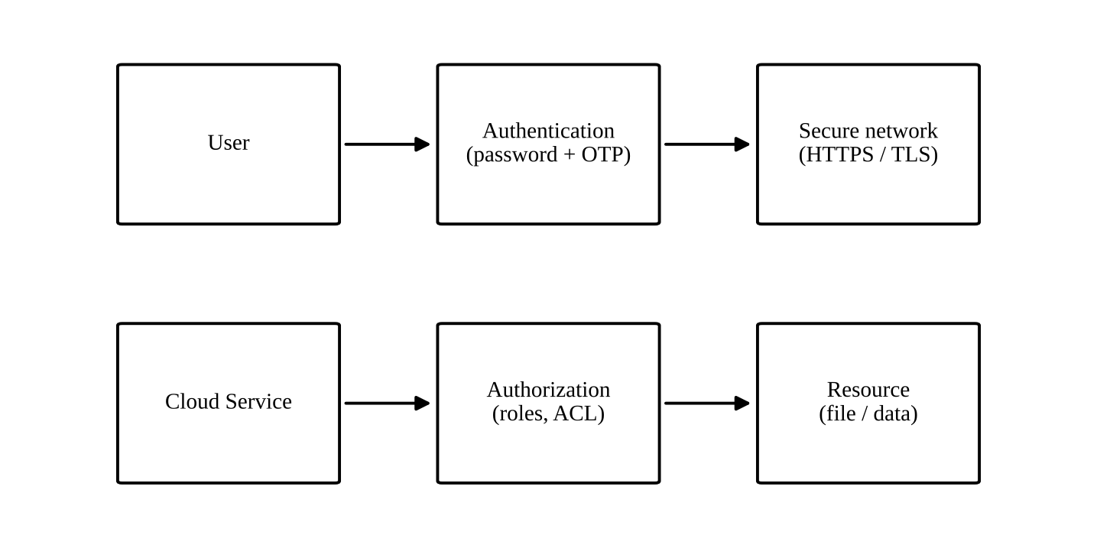
Figure 4: User → Authentication → Network → Cloud Service → Authorization → Resource

5. Points of attack and suitable security measures
Point in the flow | Possible threat | Security measure
User / login | Phishing, password guessing, stolen credentials | Multi-factor authentication, strong passwords, user awareness
Network | Eavesdropping and man-in-the-middle on public Wi-Fi | HTTPS/TLS, VPN on untrusted networks
Cloud service | Denial-of-service, vulnerable software | Provider-level protection, updates, rate limiting
Authorization | Over-permissive sharing, privilege misuse | Least-privilege roles, periodic permission review
Resource / data | Data leak, accidental deletion, ransomware | Encryption at rest, backups, version history

Student A – Security Investigation

1. Practical scenario investigated
A student signs in to Google Drive on a public Wi-Fi network and later on a home network, with and without 2-Step Verification enabled, to compare the exposure in each case.

2. Authentication mechanism documented
The authentication mechanism examined is password plus 2-Step Verification. After entering the password, Google asks for a second proof (a prompt on the registered phone or a one-time code). Even if the password is stolen, the attacker cannot sign in without the second factor.

3. Secure versus insecure access (conceptual comparison)
Aspect | Secure access | Insecure access
Login | Unique strong password + multi-factor authentication | Weak or reused password, no second factor
Network | HTTPS padlock, trusted network or VPN | Plain HTTP or unknown open Wi-Fi without protection
Sharing | Named users with minimum roles | “Anyone with the link can edit”
Devices | Updated device, screen lock, sign-out after use | Shared computer left signed in
Result | Data confidentiality and integrity preserved | Account takeover, data leak or deletion possible

4. Observations
- The browser shows a padlock and https:// when the connection is encrypted; a warning page appears if the certificate is invalid.
- With 2-Step Verification on, a password alone no longer grants access.
- Sharing settings show clearly who can view or edit, which makes accidental exposure easy to spot and correct.

5. Effect of poor security practices
Weak passwords or open sharing can lead to stolen accounts, leaked personal or academic data, deleted or altered files, spread of malware to shared contacts and loss of trust. Because one cloud account often unlocks many services, a single compromise can have a wide impact.

Joint Evaluation
Question: If cloud access is available from anywhere through the Internet, what additional security measures are necessary compared with a local application?
- Strong authentication, preferably multi-factor, since anyone on the Internet can attempt to sign in.
- Encryption of all traffic in transit and of data at rest in the provider’s storage.
- Fine-grained authorization and regular review of who can access what.
- Monitoring, alerts and audit logs for unusual sign-ins from new locations or devices.
- Protection against denial-of-service attacks and safe handling of API keys and tokens.
- Clear data-protection responsibilities with the provider (shared responsibility model), plus backups.
Evidence expected: secure-access architecture (Figure 4) + threat identification + mitigation analysis above.

Q5 – Collaboration Using Cloud-Based Services (6 Marks)

Shared Group Work
Collaboration service selected: Google Drive with Google Docs.
- A shared folder named “CO3_Team_Workspace” was created, containing a document “Project_Notes”.
- Student A is the Owner of the folder. Student B was added as an Editor, and the faculty member as a Viewer.
- Both students edited the document at the same time, and the edits were recorded in the version history.

Student A – Collaboration Design

1. Collaboration requirements
- Several people must work on one document at the same time.
- Everyone must always see the latest version.
- Different people need different levels of access.
- Changes must be traceable and reversible.

2. Collaboration workflow
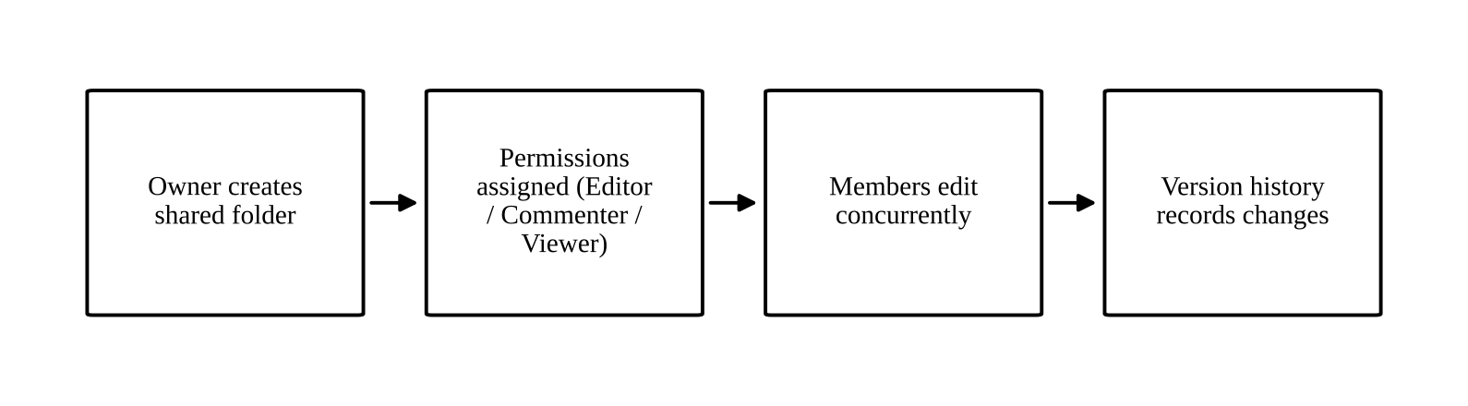
Figure 5: Cloud collaboration workflow

3. Key concepts
- Sharing: the owner shares the folder by email address or link; one copy of the file stays in the cloud and everyone works on that copy.
- Concurrent access: several users edit the same file at the same time; the service merges the edits and shows each person’s cursor and changes.
- Version control: version history stores earlier states with the editor’s name and time, so any version can be viewed or restored.
- Permission management: the owner assigns roles and can change or remove them at any time.

4. Roles of the users
User | Role | Rights
Student A | Owner | Full control: edit, share, change permissions, delete
Student B | Editor | Edit content and add comments; cannot change ownership
Faculty member | Viewer / Commenter | Read the work and give feedback without changing content

5. Justification of the sharing permissions
Editor rights let teammates contribute directly. Viewer or Commenter rights give the faculty member access for evaluation without the risk of accidental changes. Ownership stays with one person so that the folder cannot be deleted or re-shared by mistake. This follows the principle of least privilege.

Student B – Collaborative Implementation

1. Collaborative activities performed
- Activity 1: wrote and formatted the section “Cloud access methods” in the shared document while Student A edited another section at the same time.
- Activity 2: added comments and a suggestion on Student A’s section and resolved a comment after the change was accepted.

3. How changes are reflected
Edits made by one user appear on the other user’s screen within moments, with a coloured cursor naming the editor. Version history lists each saved state, so contributions of each student can be identified.

4. Collaboration issue and solution
Issue: two users edited the same paragraph and overwrote each other’s wording, and a sentence was deleted by mistake.
Solution: divide the document into sections with an owner for each, use Suggesting mode for edits in another person’s section, and use version history to restore the deleted text.

Cross-Understanding
Student B – How does cloud collaboration reduce the need to exchange multiple copies of the same file?
The file is stored once in the cloud and every collaborator opens that same file through a link or permission. There is nothing to attach and send, so no copies such as “final_v2_edited” are created. All changes go into a single version, which prevents conflicts and confusion about which copy is current, and storage space is saved.
Student A – What problems can occur if incorrect sharing permissions are given?
If permissions are too broad, unauthorised people may read confidential data, edit or delete files accidentally or maliciously, or re-share the file further. If they are too narrow, genuine collaborators cannot contribute and work is delayed. Public “anyone with the link” settings can expose the file on the Internet, and a wrong Owner or Editor assignment can lead to permanent loss of control over the file.
Evidence expected: shared workspace + contribution evidence + permission screenshots + observations above.

Q6 – Integrated Cloud Access and Collaboration Mini Investigation (7 Marks)
Scenario selected: Cloud-Based Student Project Management.

Student A – System Design

1. Problem definition
Student project teams share files through messaging apps and e-mail. Versions get mixed up, tasks are not tracked, and the guide cannot easily see progress. The problem is to provide one cloud-based space where team members can reach project files from anywhere, collaborate on them and let the faculty guide monitor progress.

2. Users
- Students (team members) who create, edit and upload project work.
- Team leader who assigns tasks and manages the workspace.
- Faculty guide who reviews work and gives feedback.

3. Cloud access methods
- Browser access to Google Drive, Docs and Sheets from lab or home computers.
- Mobile app access for quick viewing, comments and notifications.

4. Required cloud services
- Cloud storage for project files (Google Drive).
- Online document and spreadsheet tools for reports and the task tracker (Docs, Sheets).
- Identity and sharing control (Google account, role permissions).
- Notifications and comments for feedback.

5. System architecture
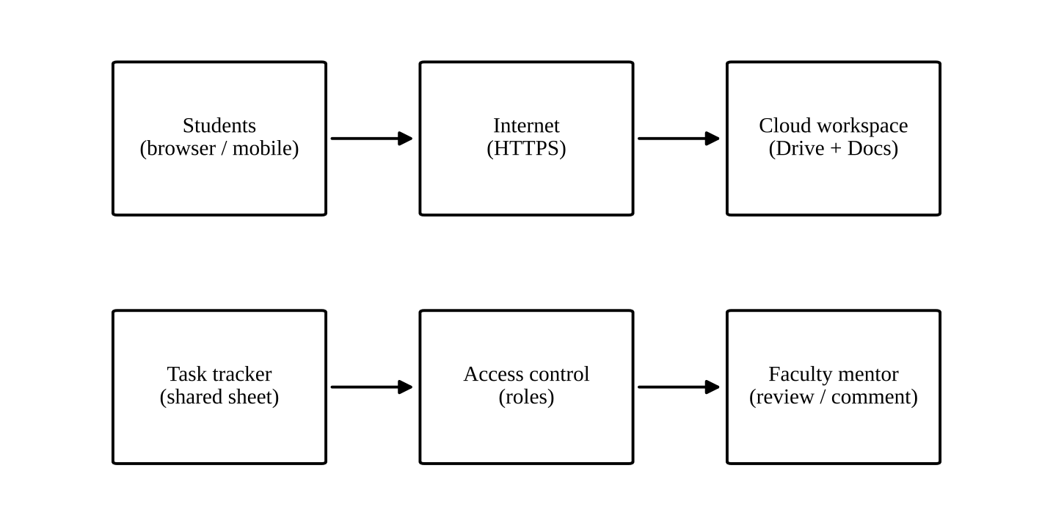
Figure 6: Architecture of the cloud-based project management system

6. How users access the system
A user signs in with an authenticated account from a browser or the mobile app. The request is sent over HTTPS to the cloud workspace, which checks the user’s role and displays the project folder.

7. How users collaborate
Team members edit the shared report and task tracker at the same time, use comments to discuss changes, and rely on version history to review contributions. The faculty guide, with Commenter rights, adds feedback directly in the documents.

Student B – Evidence and Evaluation

1. Prototype / workflow
The prototype is a shared Drive folder “Project_Workspace” with three items: a Report document, a Task Tracker spreadsheet and a Reference folder. The tracker has the columns shown below.
Task | Assigned to | Due date | Status | Remarks
Literature review | Student A | Day 2 | In progress | Sources being collected
Design diagram | Student B | Day 3 | Not started | Depends on literature review
Draft report | Team leader | Day 5 | Not started | Merge sections

2. Demonstration of cloud access and collaboration mechanisms
- Cloud access mechanism: signing in to Google Drive from the browser and from the mobile app.
- Collaboration mechanism: simultaneous editing of the Task Tracker, with comments and version history.

3. Testing using two user scenarios
Scenario | Action | Expected result | Observed result
1. Team member from a laptop | Sign in, update own task status, add a comment | Update is saved and visible to other members
2. Faculty guide from a mobile phone | Open the report as Commenter, add feedback, try to edit text | Comment is saved; direct editing is blocked

4. Analysis of results
The test checks two things: that access works from different devices and that role-based permissions behave correctly. When the outcomes match the expected results, they show that members can update their work, the guide can give feedback without changing content, and everybody sees the same up-to-date files.

5. Limitations and possible improvements
- Limitation: requires an Internet connection; no automatic reminders for due dates; the tracker is manual.
- Improvements: add automatic deadline notifications, connect forms for progress reports, enable offline editing for key files and use two-factor authentication for all members.

Joint Evaluation
Question: How does combining cloud access and cloud collaboration improve the efficiency of the proposed system?
Cloud access means every member can reach the project from anywhere and from any device at any time, and cloud collaboration means everyone works on a single shared copy. Together they remove the delay of sending files, avoid duplicate versions, make progress visible to the guide immediately, keep a record of who did what, and let work continue in parallel. This saves time, reduces errors and makes the project process more transparent.

Q7 – Day-4 Design Challenge: Design a Cloud-Based Collaborative Solution (10 Marks)

Stage 1 – Independent Design Proposals
Both initial proposals were prepared independently before any discussion and are retained as evidence.

Student A – Initial Proposal
Item | Proposal
Problem definition | Placement coordination in a college is handled through notice boards, WhatsApp and email, so students miss drives and records are scattered.
Target users | Final-year students, placement officer, faculty coordinators
Cloud access method | Browser-based access to a shared portal
Required cloud services | Cloud storage (Google Drive), Google Sheets for drive schedules, Google Forms for registration
Collaboration mechanism | Shared sheets and folders with comments; the placement officer edits and students view
Basic architecture | Users → Browser → Internet → Google Workspace → Shared Drive / Sheets

Student B – Initial Proposal
Item | Proposal
Problem definition | Placement information reaches students late and in different formats; companies and officers cannot update records quickly or get notified.
Target users | Students, placement cell staff, visiting company representatives
Cloud access method | Mobile application plus a REST API for notifications
Required cloud services | Cloud database, cloud authentication service, push notification service, object storage for resumes
Collaboration mechanism | Role-based access so the placement cell edits records and companies upload job descriptions; comments on applications
Basic architecture | Users → Mobile app → Internet → Cloud API → Cloud database / storage

Stage 2 – Design Comparison Record
Criteria | Student A’s design | Student B’s design | Decision
Where designs agree | Same problem (placement coordination), same main users, cloud storage required | Same | Retain
Access method | Browser only | Mobile app and API | Support both browser and mobile
Strengths | Quick to set up, low cost, familiar tools | Notifications, structured data, role-based access | Combine
Weaknesses | No alerts; limited structure; sharing errors likely | Higher development effort; needs maintenance | Use ready-made services where possible
Security | Depends on sharing settings; no role model beyond the folder | Stronger authentication and roles | Adopt roles + multi-factor authentication
Accessibility | Works on any device without installation | Mobile-friendly but needs installation | Browser access as base, mobile for alerts
Collaboration requirements | Co-editing of shared sheets | Record-level updates by roles | Retain shared sheets and add comments
Missing components | Notifications, access logs | Document co-editing, low-cost start | Add both to the final design

Stage 3 – Joint Final Design
Design element | Final decision
Problem | Provide one cloud platform for placement drive announcements, registration, document sharing and status tracking.
Users | Students, placement officer, faculty coordinators, company representatives
Cloud access method | Web browser as the primary method; mobile app/browser on phones for alerts; API for notifications
Network requirements | Internet or campus Wi-Fi with HTTPS; adequate bandwidth for uploads
Cloud service / platform | Google Workspace (Drive, Sheets, Forms) supported by Google Cloud services for identity and notifications
Web application / API requirement | Web application for forms and dashboards; REST API to send alerts and read drive data
Collaboration mechanism | Shared sheets and folders with comments and version history; role-based editing
Authentication / security | Institutional account sign-in, 2-Step Verification, HTTPS/TLS, least-privilege roles, access logs
Data / resource sharing | Students: view drives and upload own resume. Placement cell: edit all records. Companies: upload job description only.

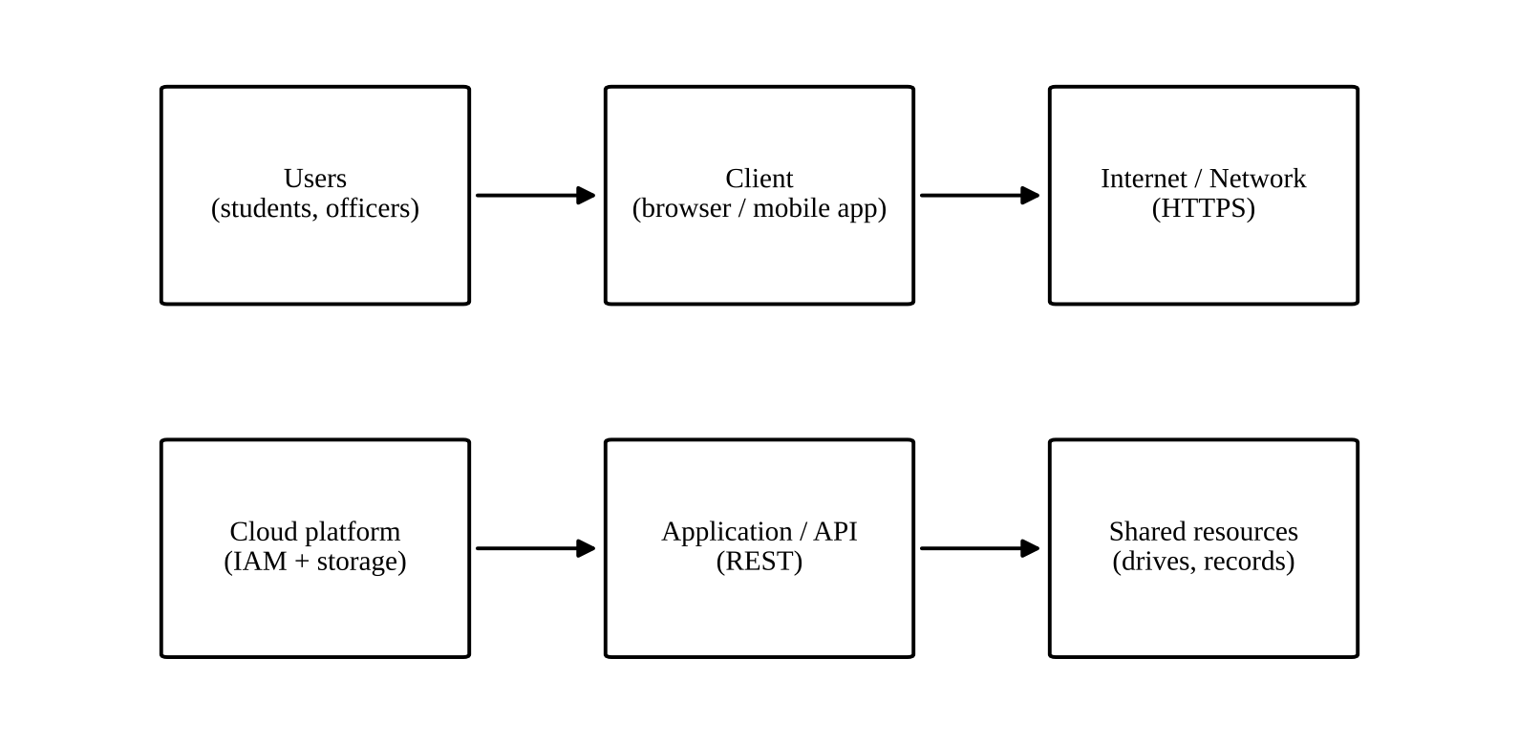
Figure 7: Users → Client → Internet/Network → Cloud Platform → Application/API → Shared Resources

Complete system workflow
- 1. The placement officer signs in and creates a drive entry in the shared sheet.
- 2. The system notifies students through the API and mobile alerts.
- 3. Students sign in (browser or mobile), view the drive and register through a form.
- 4. Students upload resumes to their own folder; access is limited to themselves and the placement cell.
- 5. Company representatives upload job descriptions to the drive folder.
- 6. Placement staff edit selection status together; changes are visible immediately and tracked in version history.
- 7. Students see their status; faculty coordinators review reports.

Stage 4 – Validation

Student A – Technical Validation
- Cloud access method: browser access is chosen as the base because it needs no installation and works on any device; mobile access is added for timely alerts.
- Platform justification: Google Workspace already provides storage, co-editing, forms, identity and sharing controls, which reduces cost and development time for a college.
- Architecture: clients connect over HTTPS to the cloud platform, which authenticates users, applies role permissions and serves the application and shared resources.
- API / web access: the web application is used for daily operations, and the API sends notifications and reads schedule data automatically.
- Suitability: the design is suitable for a college-sized user group, scales by adding users to the platform and is easy to maintain.

Student B – Experimental Validation
Test cases designed for the solution:
No. | Test case | Expected behaviour | Observed behaviour
T1 | Student signs in from a laptop browser | Student sees the drive list and can register
T2 | Student opens the system from a mobile phone | Same data visible; layout adapts to the screen
T3 | Student tries to open another student’s resume folder | Access denied (authorization works)
T4 | Placement officer edits status while a coordinator edits the same sheet | Both changes are saved and visible to both
T5 | Company representative tries to edit selection status | Edit not allowed; upload to own folder only
T6 | Access on a slow network | Pages load slowly but data is not lost; upload can be retried

Expected and observed behaviour are compared for each test case. Any mismatch is recorded together with the reason and the corrective action.

Stage 5 – Cross-Defence
Student A – What experimental evidence supports the group’s cloud design?
The test cases and screenshots provide the evidence. Successful sign-in from different devices shows the access method works. Denied access to another user’s folder shows the authorization works. Simultaneous editing by two staff members without lost changes shows that collaboration works. Behaviour on a slow network shows how the system copes with limitations, and the comparison between expected and observed results confirms the design meets its requirements.
Student B – Why was the selected cloud access and collaboration approach chosen?
Browser access was chosen because the users include students and staff with different devices, and no installation is required. Mobile and API notifications were added because the main weakness of Student A’s design was missed announcements. Real-time shared editing with role-based permissions was chosen because it prevents duplicate files and conflicts and limits who can change records. A ready-made platform was used to save cost and time while still meeting security needs.

Stage 6 – Joint Evaluation
Aspect | Evaluation
Benefits of the solution | Single source of information, access anywhere, instant updates, reduced paper and messaging, traceable changes
Access-related limitations | Requires Internet; poor connectivity in some areas; users need accounts and basic training
Collaboration benefits | Simultaneous editing, comments, no duplicate files, clear roles
Security risks | Account compromise, wrong sharing settings, exposure of personal data such as resumes and marks
Scalability | Cloud storage and services scale with the number of users and drives; platform quotas must be monitored
Possible improvements | Offline access, automatic reminders, dashboards for statistics, integration with the college information system
Situations where the approach may not be appropriate | Locations without reliable Internet; highly confidential data requiring on-premises control; very large-scale or specialised workflows beyond the platform’s limits

Final Question: What characteristics should a system designer consider before selecting cloud-based access and collaboration for a real-world application?
- Users and their devices: who will use the system, from where, and on what devices.
- Connectivity: reliability and bandwidth of the network, and the need for offline use.
- Security and privacy: sensitivity of the data, authentication needs, legal or institutional rules.
- Access control: roles, permissions and auditing requirements.
- Collaboration needs: number of simultaneous users, real-time editing and version tracking.
- Scalability and performance: expected growth and peak load.
- Cost and maintenance: subscription, development and support effort.
- Availability and reliability: provider uptime, backups and recovery.
- Integration and portability: APIs, compatibility with existing systems and avoiding vendor lock-in.

Contribution Record
Question | Student A – Primary Contribution | Student B – Primary Contribution | Joint Work
Q1 | Access method design, classification and architecture diagram | Practical access demonstration, screenshots, observations and limitation | Study of access methods; selection of Google Drive; cross-verification
Q2 | Platform analysis, request mapping and interaction diagram | Application investigation (Google Docs), user-action sequence, benefits | Platform selection, comparison and local-versus-cloud evaluation
Q3 | API design, request/response components and flow diagram | Python client, execution, tests and analysis of results | API selection and joint analysis of API-based access
Q4 | Security investigation, authentication, secure versus insecure comparison | Security design, considerations, secure flow, attacks and measures | Study of security issues; joint evaluation
Q5 | Collaboration design, workflow, roles and permission justification | Collaborative activities, permission screenshots, issue and solution | Workspace creation, sharing settings and cross-understanding answers
Q6 | Problem, users, services and architecture | Prototype, tests with two user scenarios, analysis and improvements | Scenario selection and joint evaluation
Q7 | Initial proposal A; technical validation | Initial proposal B; test cases and experimental validation | Comparison record, joint final design, cross-defence and evaluation

Primary contribution does not mean exclusive responsibility. Both students are accountable for the complete assignment.

